1. **Libraries Required:**

* PiRGBArray
* Picamera
* Numpy
* Imutils
* cv2
* RPi.GPIO
* time

1. **Servo Initialization:**

servoPIN = 17 #Connect your 17pin of raspberry pi to servo or any motor you want to control.

servoAngle= 90 # For user decision, servo angle when motion detected.

GPIO.setmode(GPIO.BCM)

GPIO.setup(servoPIN, GPIO.OUT)

p = GPIO.PWM(servoPIN, 50) # GPIO 17 for PWM with 50Hz

p.start(0) # Initialization,start at 0 duty cycle so it doesn't set any angles on startup

1. **Camera Setting:**

# initialize the camera and grab a reference to the raw camera capture

camera = PiCamera()

camera.resolution = tuple([640, 480]) #Set camera Resolution

camera.framerate = 16 # 16 frame per sec

rawCapture = PiRGBArray(camera, size=tuple([640, 480])) # rgb capturing directly

print("[INFO] warming up...")

time.sleep(2.5) # camera starting time

firstFrame = None # first frame for comparison

motionCounter = 0 # motion required for detecting an animal and starting the servo

minmotion = 5 # minmum motion for servo working

1. **Animal color Range RGB**

lower = [65, 49, 28]# for color range of animal start to end

upper = [187, 159, 174] # Setting up the color range of animal

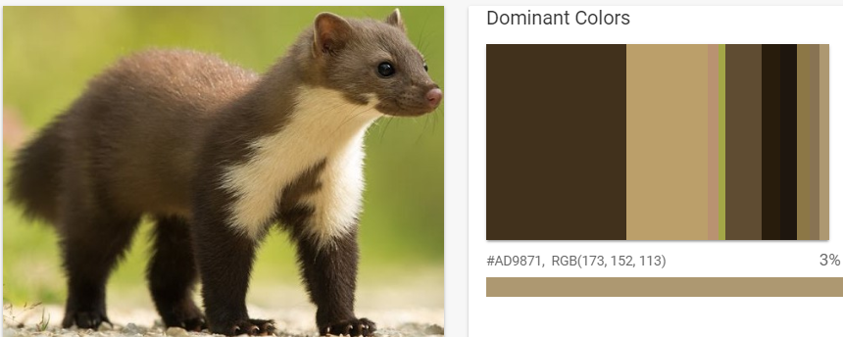

1. **General Code:**

for f in camera.capture_continuous(rawCapture, format="bgr", use_video_port=True):

# grab the raw NumPy array representing the image and initialize

# the timestamp and occupied/unoccupied text

frame = f.array

text = "No Motion"

framecopy=frame.copy()

# resize the frame, convert it to grayscale, and blur it

frame = imutils.resize(frame, width=500)

gray1 = cv2.cvtColor(frame, cv2.COLOR_BGR2GRAY)

gray = cv2.GaussianBlur(gray1, (21, 21), 0)

# if the first frame is None, initialize it

if firstFrame is None or p==200:

p=0

firstFrame = gray.copy()

rawCapture.truncate(0)

continue

p=p+1

# accumulate the weighted average between the current frame and

# previous frames, then compute the difference between the current

# frame and running average

cv2.accumulateWeighted(gray, firstFrame, 0.5)

frameDelta = cv2.absdiff(gray, cv2.convertScaleAbs(firstFrame))

# threshold the delta image, dilate the thresholded image to fill

# in holes, then find contours on thresholded image

thresh = cv2.threshold(frameDelta, 5, 255, cv2.THRESH_BINARY)[1]

thresh = cv2.dilate(thresh, None, iterations=2)

cnts = cv2.findContours(thresh.copy(), cv2.RETR_EXTERNAL,cv2.CHAIN_APPROX_SIMPLE)

# loop over the contours

cnts = cnts[0] if imutils.is_cv2() else cnts[1]

for c in cnts:

# if the contour is too small, ignore it

if cv2.contourArea(c) < 600:

continue

# compute the bounding box for the contour, draw it on the frame,

#print(cv2.contourArea(c))# and update the text

(x, y, w, h) = cv2.boundingRect(c)

ccc=framecopy[y: y+h, x: x+w].copy()

# find the colors within the specified boundaries and apply

# the mask

mask = cv2.inRange(ccc, lower, upper)

kernel = cv2.getStructuringElement(cv2.MORPH_RECT, (25, 1))

detectarea = cv2.morphologyEx(mask, cv2.MORPH_CLOSE, kernel)

contours = cv2.findContours(detectarea.copy(), cv2.RETR_EXTERNAL, cv2.CHAIN_APPROX_NONE)

contours = contours[0] if imutils.is_cv2() else contours[1]

#mask = np.zeros(ccc.shape, dtype=np.uint8)

for d in contours:

if cv2.contourArea(d) < 3000:

continue

#print(cv2.contourArea(d))

text1= "Detected"

cv2.putText(frame, "Animal: {}".format(text1),(10, frame.shape[0] - 10), cv2.FONT_HERSHEY_SIMPLEX, 0.35, (0, 0, 255), 1)

cv2.rectangle(frame, (x, y), (x + w, y + h), (0, 255, 0), 2)

motionCounter += 1

if motionCounter > minmotion:

minmotion = 0

duty = servoAngle / 18 + 2

GPIO.output(servoPIN, True)

pwm.ChangeDutyCycle(duty)

sleep(1)

print("Servo start")

text = "Motion Detected"

# draw the text and timestamp on the frame

cv2.putText(frame, "Status: {}".format(text), (10, 20),cv2.FONT_HERSHEY_SIMPLEX, 0.5, (0, 0, 255), 2)

# show the frame and record if the user presses a key

# check to see if the frames should be displayed to screen

if showvideo=="yes":

# display the security feed

cv2.imshow("Security Feed", frame)

key = cv2.waitKey(1) & 0xFF

# if the `q` key is pressed, break from the lop

if key == ord("q"):

break

# clear the stream in preparation for the next frame

rawCapture.truncate(0)

p.stop()

GPIO.cleanup()

GPIO.output(servoPIN, False)

pwm.ChangeDutyCycle(0)

